



Many of the plants that are commonly seen in our gardens are poisonous. The list below is a guide to many plants that you may have in your school garden or allotment, but there are more! If in doubt, please check!

General health and safety rules when gardening are quite straightforward:
- Always wear gardening gloves.
- Always wash your hands after gardening.

Name of plant | Image | Poisonous parts | Where it grows
Deadly nightshade | 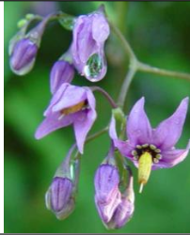 | All parts, but especially the berries | Mainly in the south of the UK in woodland and along paths and shrubby areas.
Foxglove | 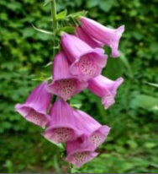 | Ingestion of any parts can result in severe poisoning. | Grows throughout the UK – gardens, hedgerows, woodland and roadside verges.
Buttercup | 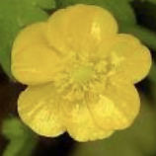 | Ingestion of any part can cause inflammation of the tongue and vomiting. | Grows throughout the UK - fields, gardens, roadside verges and woodland.
Azalea/Rhododendron | 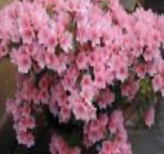 | Ingestion of any part can cause nausea, breathing difficulties and coma. | Grows throughout the UK – gardens, woodlands and parks.
Ivy | 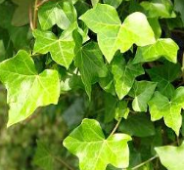 | Ingestion of the leaves can cause breathing difficulty, convulsions and coma. | Grows throughout the UK – gardens, woodlands, parks, alongside paths, shrubby areas and roadside verges.
Laburnum | 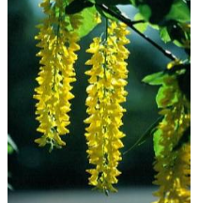 | Ingestion of the seeds/pods can cause convulsions and could be fatal. | Grows throughout the UK in gardens and parks.
Privet | 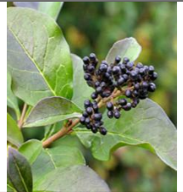 | Ingestion of the berries can cause stomach pains. | Wild privet is a native of the British Isles and can be found in hedgerows and woodlands in southern England and Wales – less common in northern England.  Garden privet is a common hedging plant.
Elder | 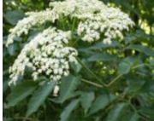 | Ingestion of any part can cause digestive difficulties. | Elder is a widespread shrub or tree and can be found at the edges of woodlands, hedgerows and scrubby areas.
Rhubarb | 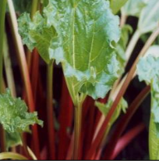 | Ingestion of any of the leaves, either raw or cooked can cause convulsions/coma and could be fatal. | Rhubarb is a popular garden/allotment plant and grows particularly well in parts of West Yorkshire.
Yew | 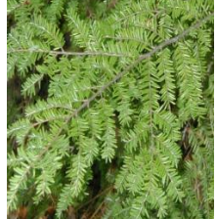 | This is the most poisonous of all!  Ingestion of the leaves or berries can cause sudden death! | Yew is often found in the grounds of churches, but can also be found in gardens.
Daffodil  Hyacinth | 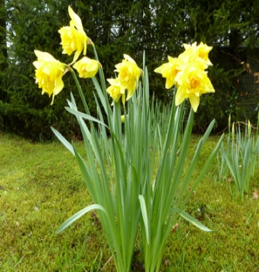  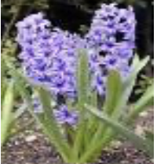 | Ingestion of the bulbs can cause nausea and vomiting. | Daffodil and hyacinths are popular spring flowers found in gardens and in the case of daffodils by roadsides and in woodland.
Lords-and-ladies (also known as cuckoo pint) | 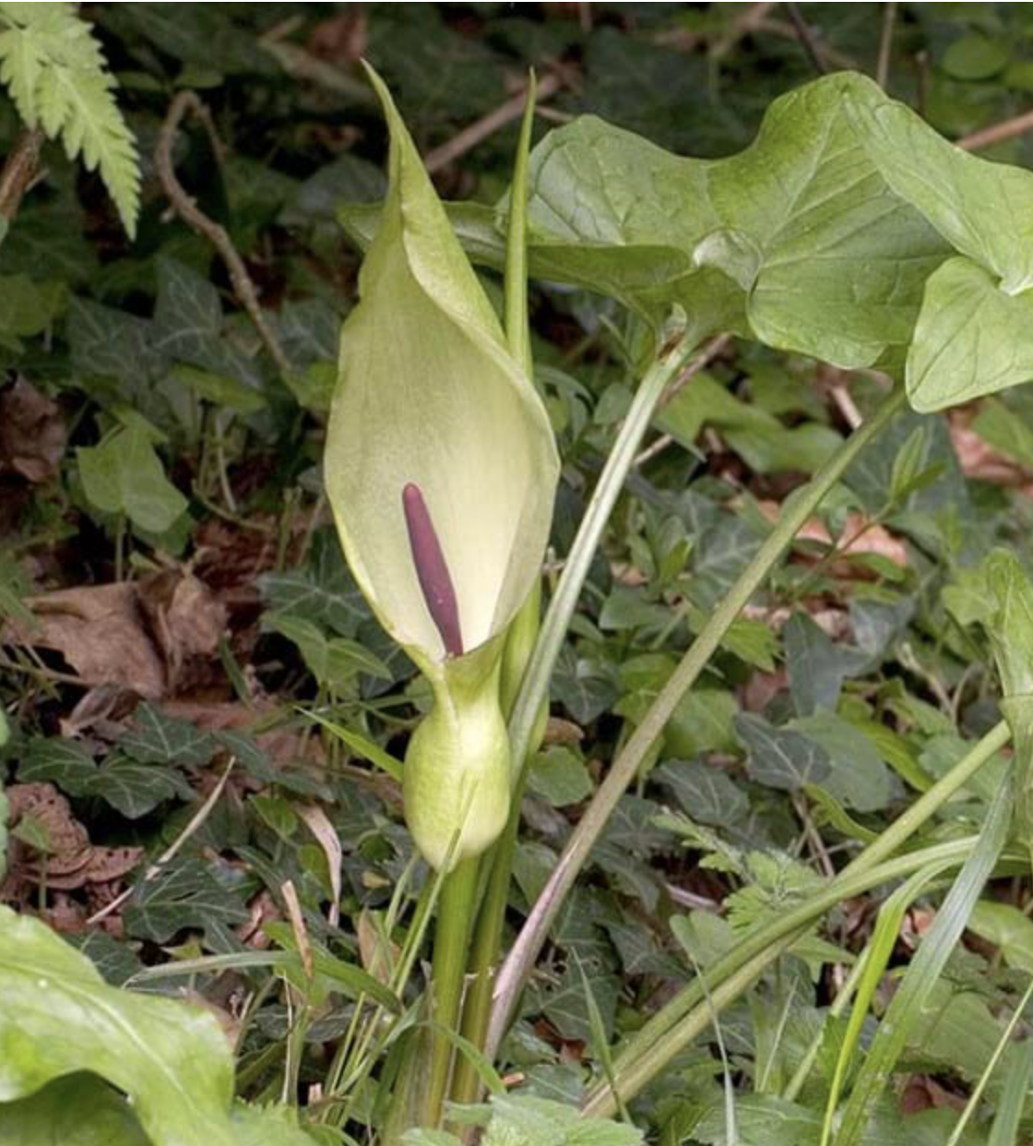 | All parts of this plant can cause allergic reactions, but the berries are particularly poisonous. | Lords-and-ladies can be found in woodland and along hedgerows.

For further information, please go to the following websites:
https://www.rhs.org.uk/prevention-protection/potentially-harmful-garden-plants

https://hta.org.uk/potentiallyharmfulplants

